pmc sUNDAY sCHOOL LESSON PLAN FOR NOVEMBER 2020 FOR ALL AGES

THEME: ARE YOU READY?

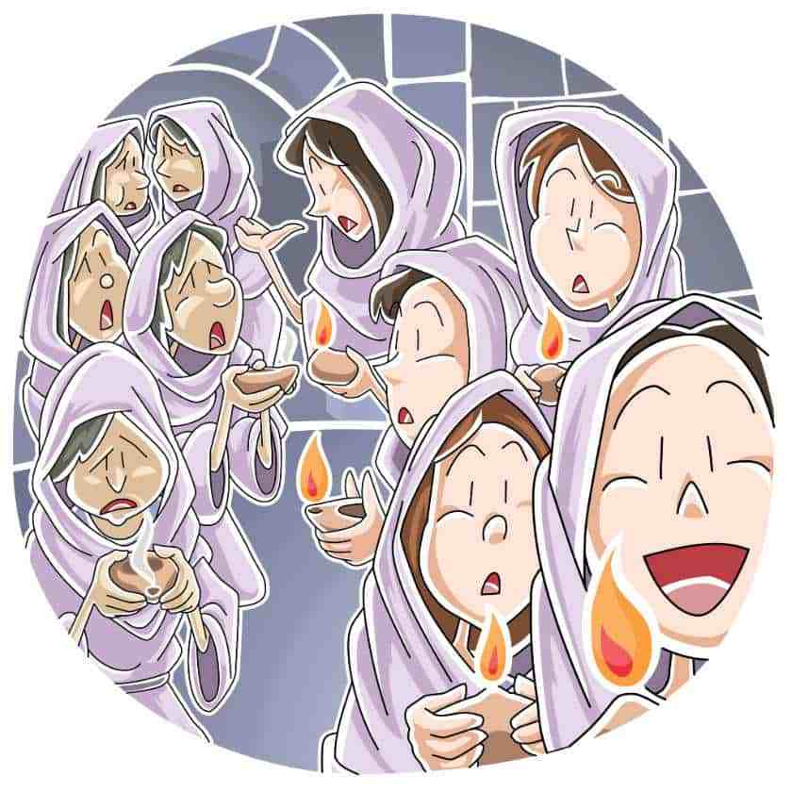

image taken from ministry-to- ministry.com

PREPARATION SONG

https://www.youtube.com/watch?v=Bopa6jHReqk

READ MATHEW 25: 1-13
- younger children can use: https://www.biblegateway.com/passage/?search=MATTHEW+25%3A1-13&version=CEV

- older children can use:

https://www.biblegateway.com/passage/?search=MATTHEW+25%3A1-13&version=NRSV

younger children can watch this

https://www.youtube.com/watch?v=KJiM3qKGzoY

quiz time
- How many bridesmaids were there?
- How many were foolish and how many were wise?
- The foolish bridesmaids did not take an item with them. What was it that they did not take?
- Who was delayed?
- What were the bridesmaids doing during the “delay”?
- What happened at midnight?
- What did the foolish bridesmaids ask the wise bridesmaids?
- How did the wise bridesmaids reply?
- When the bridegroom came, where did the wise bridesmaids go?
- Look at verse 10. Explain in your own words what it says.
- Repeat what the last part of verse 10 says?
- What did the foolish bridesmaids ask the Lord when they came back?
- What did the Lord reply?
- Read verse 13 aloud.

The younger children can go onto the activities appropriate for them AND THEN END WITH PRAYER

further discussion for the older children (Juniors to youth)– what does this parable mean?
Context first.
Back then bridesmaids carried oil lamps so that everyone could see including seeing the groom. With light people could see how well the groom was dressed indicating how he would make a good husband who would take care of his bride. Jesus was speaking to his disciples on the Mount of Olives about the end of the Age. He had explained to them that no one knew when the end would happen. In his teaching to his disciples, Jesus told this parable, a story that his disciples could relate to but the story had a twist.

What does the story mean?
The delayed arrival of the groom represents the return of Jesus. No one knows when Jesus is returning. The bridesmaids did not know when the groom would appear. The wise bridesmaids were prepared but the foolish ones were not and they were locked out of the banquet hall. In the same way those that are prepared for Jesus’ coming will enjoy the heavenly feast but not the others.

Discussion Point
Are you ready? How can you get ready and stay ready? The most important step is repentance and acceptance of Jesus Christ.

Watch this: https://www.providencemethodistja.com/videos-1 (scroll to the bottom of the page for the video “10 Bridemaids”)
https://www.youtube.com/watch?v=WjZ01FcK0yk

PRAYER
Lord thank you that you gave us everything we need to be ready for your return but help us to be obedient so that we are indeed prepared. Help us submit our hearts to Jesus and study the scriptures and pray. Help us to make good moral choices. Help us to receive the Holy Spirit so that we can be guided through life and give light to others. Amen.

THINK ABOUT THE STORY WE HAVE JUST READ. DISCUSS WHAT IS HAPPENING HERE. COLOUR THE PICTURE
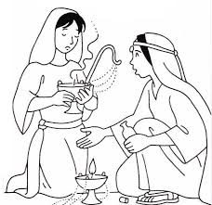

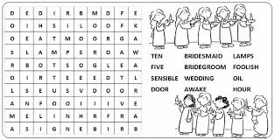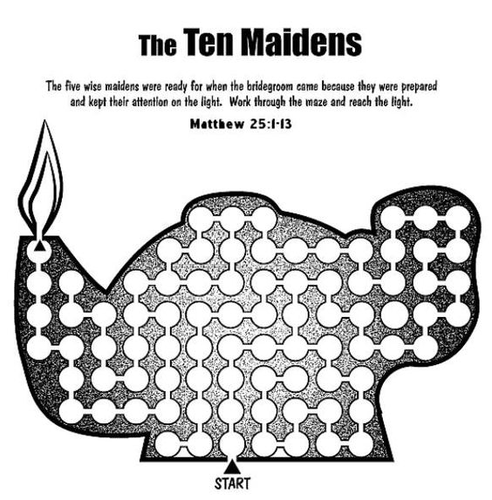
FOR THE OLDER CHILDREN

